Student’s name | …………………………………………………….…… | Grade | 5
Subject | Computer | Week No. | 15
Lesson Title | Slide Master | Unit
Worksheet No. ( 15 ) (Answer)
Question A: Fill in the blanks with the words in the box below.
Toolbar | Project Library | Video preview | Timeline
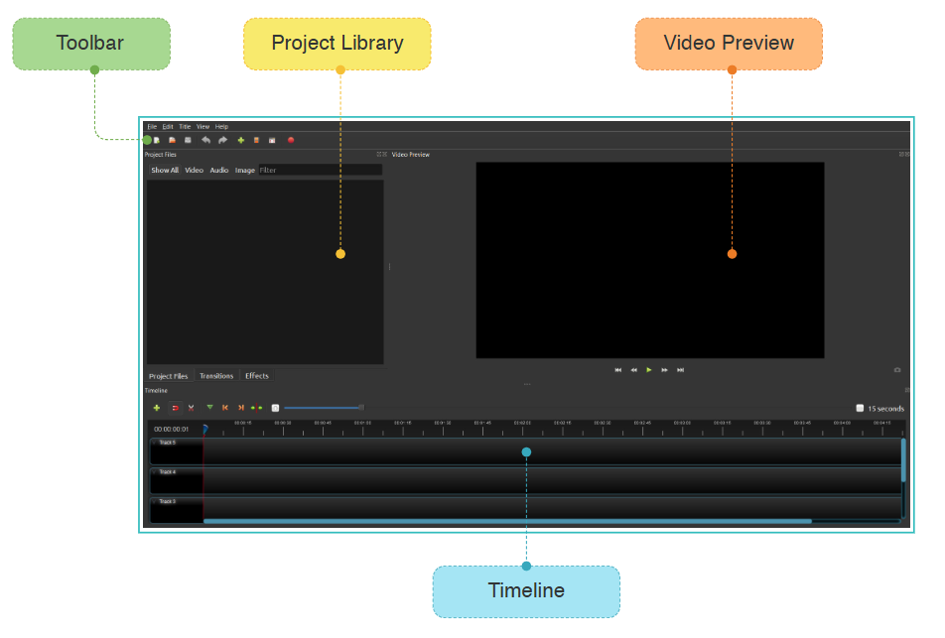

Good Luck

